WELCOME KEVIN COLWELL
Vol. 2, Issue 1 • Spring 2016
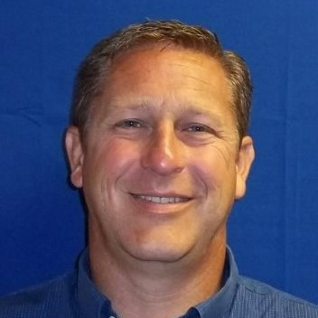
Kevin Colwell graduated Magna Cum Laude from the College of St. Francis in Joliet Illinois with a Business Administration degree. Kevin spent 19 years at TJ Lambrecht Construction - initially as the HR Manager, EEO Manager, and Safety Manager. His passion (and eventual full time title) was the Corporate Safety Director position which he held until TJL closed it’s doors in early 2013. Since that time, Kevin has had the pleasure of working with terrific people in the petrochemical, mechanical, and energy industries, taking lessons some from of the best managerial safety programs in the world.

Kevin’s philosophy toward safety is best described as collaborative. Kevin likes to get to know every employee and work method. Don’t be surprised if in the coming weeks he asks to work with your crew (think: Mike Rowe from Dirty Jobs) for the day to fully understand the ins and outs of the job and provide workable real world safety initiatives.

Kevin has been a lifelong Southside resident, and currently resides in Minooka Illinois with his two children. In his free time he enjoys watching the Blackhawks, snowmobiling in the winter, and driving the boat for his kids in the summer (who don’t stop tubing until the boat is out of gas….)
SAFETY COMMITTEE MEMBERS:
Justin Jonkman | Brian Ludke
Steve Caraway | Charlie Meyer
Danny Sullivan | Paul Yerkes
Brian Schnieder | Curtis Husch
Mike Ulanowski | John Cofran
Chris Wirkus | Jimmy Parker
Mike Burdick | Chey Hasemeyer
Andy Kritikos | Jonathan Gallagher
Mary Beth Howard

A Message to a Captive Audience
Beginning last May, Gallagher Asphalt joined a Captive.
What is a Captive?
A captive is basically a pool of high-performing, safety-driven companies that have joined together to “insure” themselves and each other.
The individual member companies of the captive are essentially responsible for covering any initial claims from their annual deductible. Once the deductible has been met, the captive covers some or most of the remaining claim costs.
Getting “accepted” into this particular high-caliber captive is not easy. It is an elite group of best-in-class companies that have worked hard through the years to have enviable safety records. Given that we are and always have been a company that truly values a culture of safety, we are proud to have been admitted into this select group.
In fact, Gallagher Asphalt is currently celebrating a record-setting insurance industry safety score this year within our industry.
So what does this mean for all of us?
It means that ALWAYS thinking about safety and acting safely day-in and day-out is absolutely crucial; not only from a financial perspective, but more importantly from a health and safety perspective.

